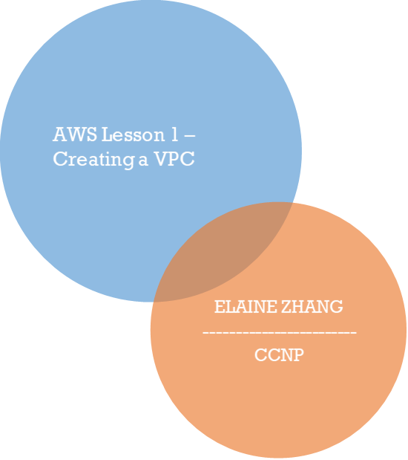

**Purpose:**

This activity asks students to create an Amazon Virtual Private Cloud. First, constructing public and private subnets so that the appropriate VPC functions are accessible to customers and internal organization members. Then, constructing an internet gateway and route table.

**Problems:**

The only issue that arose during this activity was with overlapping IP addresses between the two VPCs. Initially, I configured the subnets of both VPCs with the exact same addresses but had to switch those of the second VPC to 10.0.3.0 and 10.0.4.0 addresses after the overlap caused issues. Avoiding using the same addressing schemes was something I kept in mind while configuring the default gateway and route table of the second VPC as well.

**Screenshots:**

VPCs:

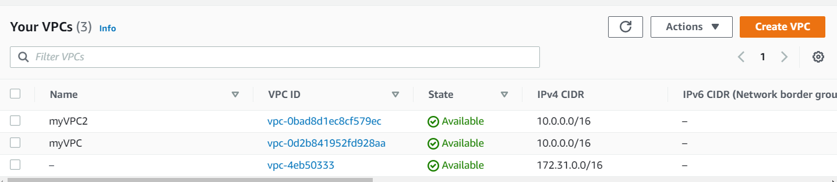

Public and private subnets:

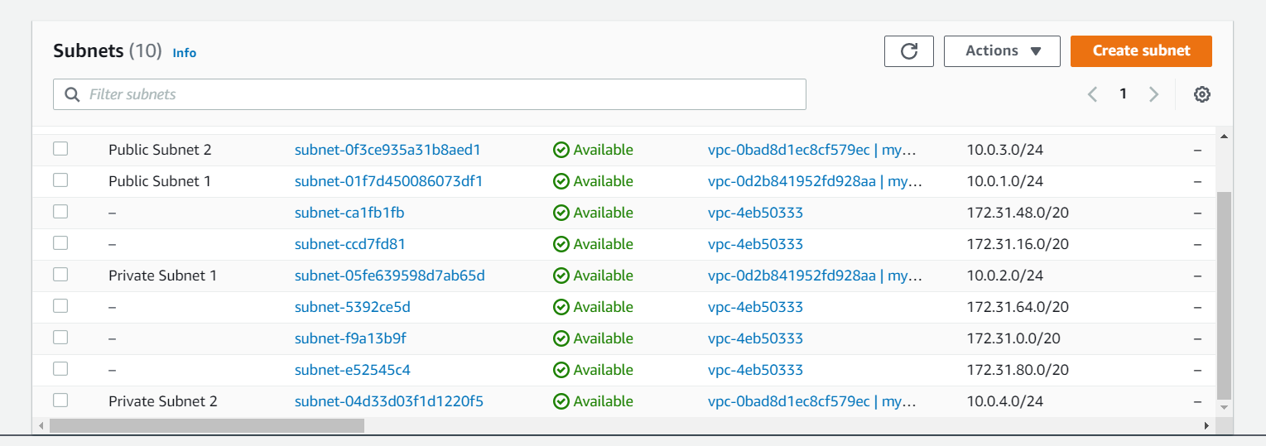

Internet gateways:

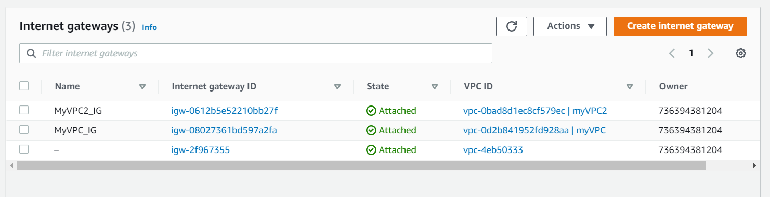

Route tables:

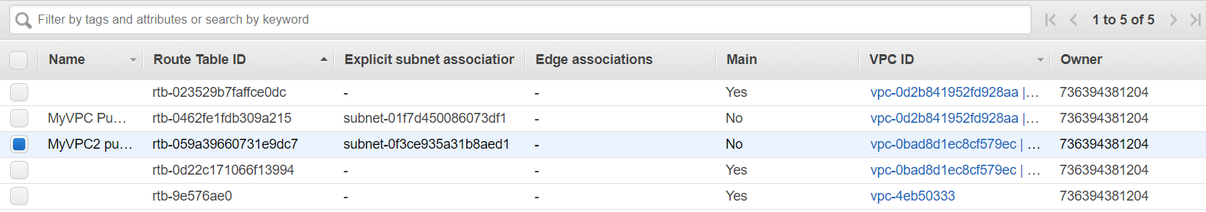

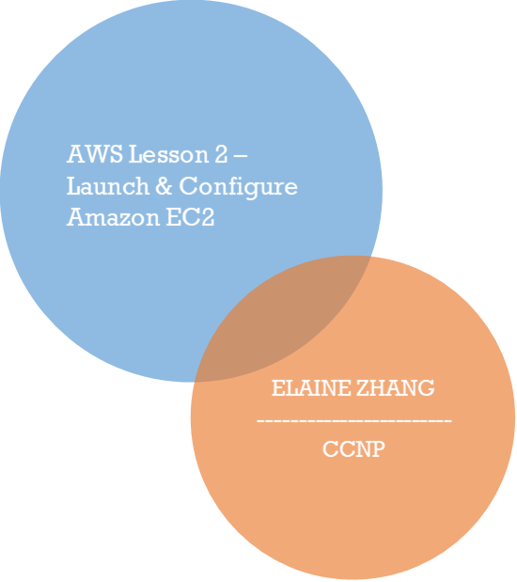

**Purpose:**

This activity asks students to launching an instance of a S3 bucket to host a publicly accessible static website. First, creating the S3 bucket, then configuring static website hosting. Once this has been completed, the website files can be uploaded to the bucket. After the correct public accessibility permissions and bucket policies have been configured, the website should be publicly accessible to clients.

**Problems:**

The first issue that arose was with uploading the correct website files to the S3 bucket. After downloading the website file folder, I uploaded the folder as an object while I should have uploaded the photo and html files separately. Next, I did not copy the bucket policy template correctly and had to edit it multiple times to make sure the code I had created matched that in the instructions.

**Screenshots:**

Configured website:



Objects:

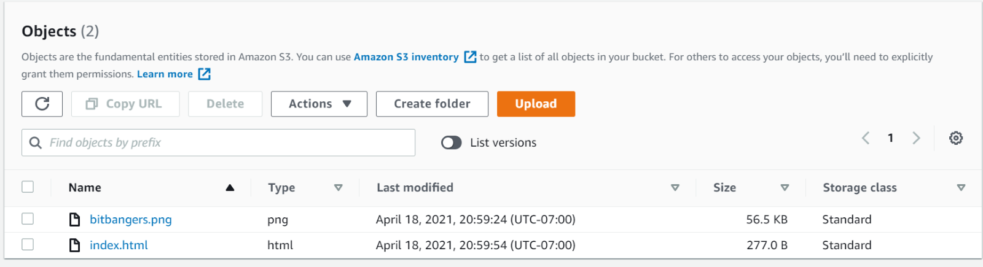

Bucket Policy:

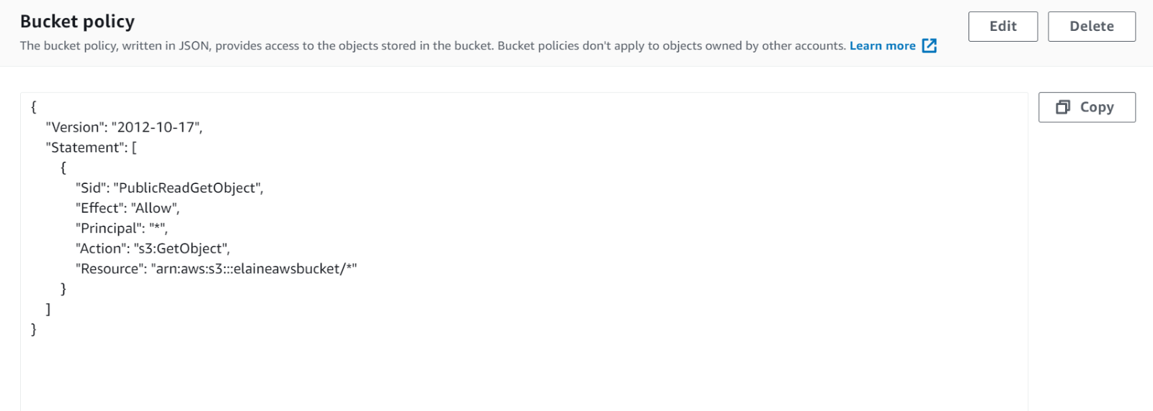

**Purpose**

In this lab, students must configure a publicly accessible webserver for a company to launch their product online to clients.

**Problems**

This lab was extremely straightforward. However, one issue was that the instance would not run properly after copying the user data bash script. The commands were not spaced correctly so I reformatted the spacing to make sure the instance accepted this piece of user data.

**Screenshots**

Launching EC2 instance

Creating security group

**Purpose:**

In this lab, students act as engineers creating a virtual private network for the company BitBeat’s cloud infrastructure, specifically using the VPC Wizard feature offered by AWS. This VPC contains public and private subnets, with the public subnet also requiring students to configure a NAT instance.

**Problems:**

The first issue I encountered while completing this lab was when I was creating a VPC in the VPC Wizard. Although the lab instructions told us to choose the “Use NAT instance instead” link, this option was not available in the actual console. Instead, I had to create a separate elastic IP address and enter its ID. Once I entered that, the AWS console informed me that my specific account did not have permission to access this feature. So, I used my classmate Yuna’s account instead, entered the same information into the VPC Wizard, and was able to successfully complete the lab.

**Screenshots:**

BitBeat 200 VPC:

Route tables:

Internet gateways:

